W7 - FUNDAMENTAL PROGRAMMING STRUCTURES IN JAVA

**LAPORAN PRAKTIKUM**

Disusun untuk memenuhi tugas Mata Kuliah Pemrograman Berorientasi Objek

Disusun oleh

Nazwa Fitriyani Zahra 211511051



**PROGRAM STUDI D3 TEKNIK INFORMATIKA**

**JURUSAN TEKNIK KOMPUTER DAN INFORMATIKA**

**POLITEKNIK NEGERI BANDUNG**

**2022**

1. **Studi Kasus 1 : Another Type of Employee**

**//Firm.java**

**//Staff.java**

**//StaffMember.java**

**//Employee.java**

**//Executive.java**

**//Hourly.java**

**//Volunteer.java**

Hasil Output :

**//Commission.java**

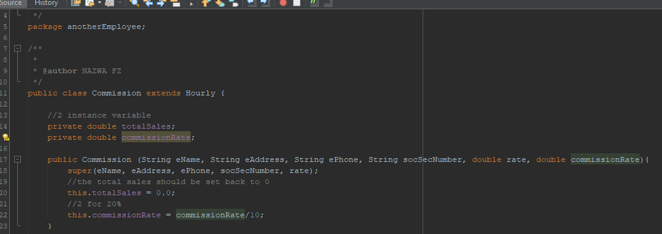

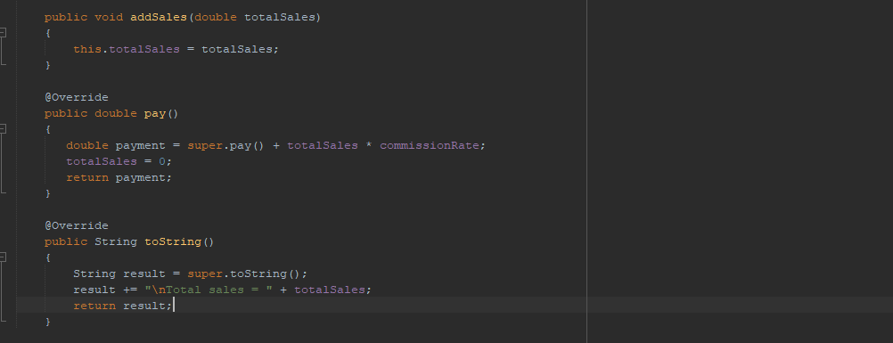

//Staff.java

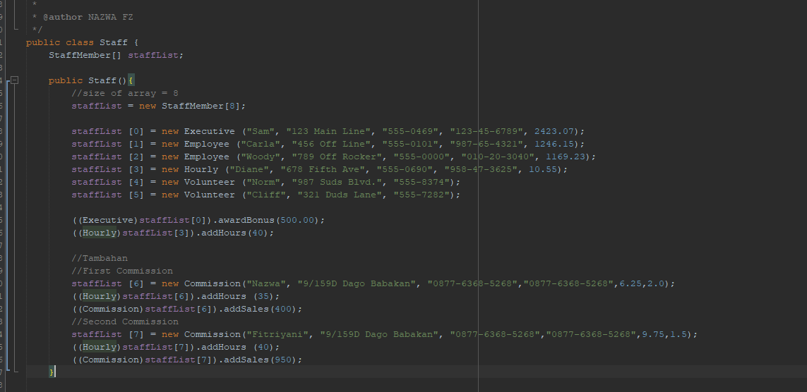

Hasil Output :

1. **Studi Kasus 2 : Painting Shapes**

**//Sphere.java**

**//Paint.java**

**//PaintThings.java**

**//Rectangle.java**

**//Cylinder.java**

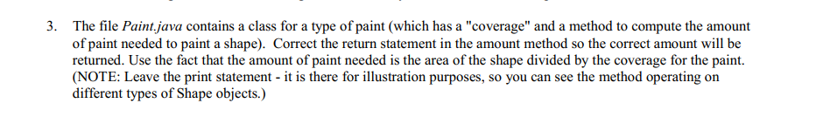

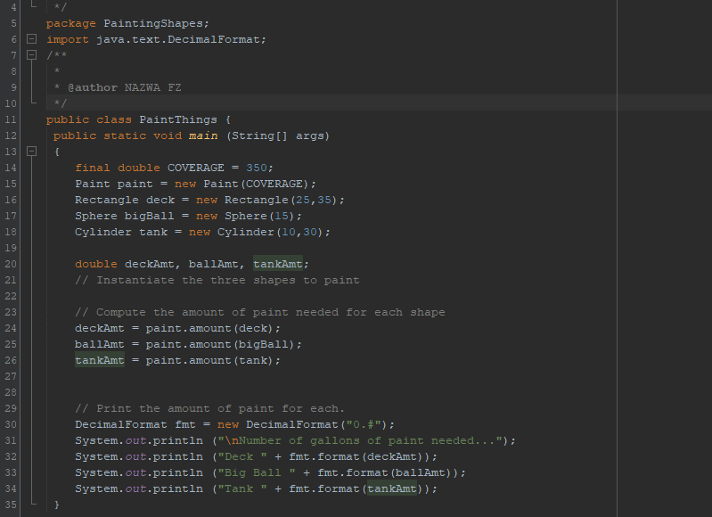

**Hasil Output :**

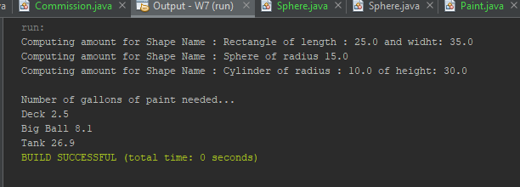

1. **Studi Kasus 3 : Polymorphic Sorting**

**//Sorting.java**

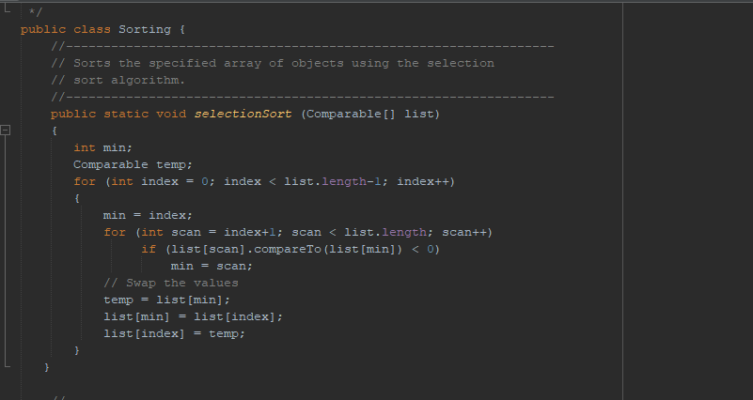

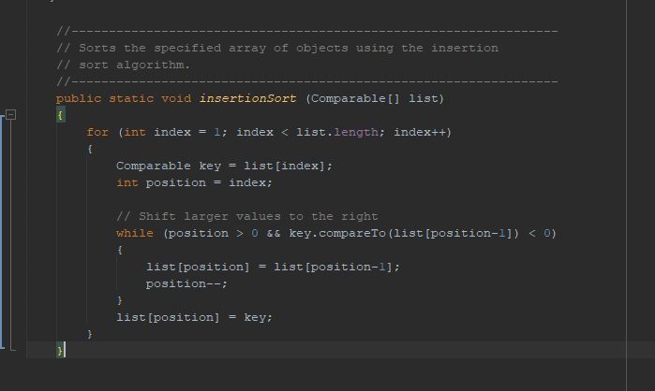

**//Numbers.java**

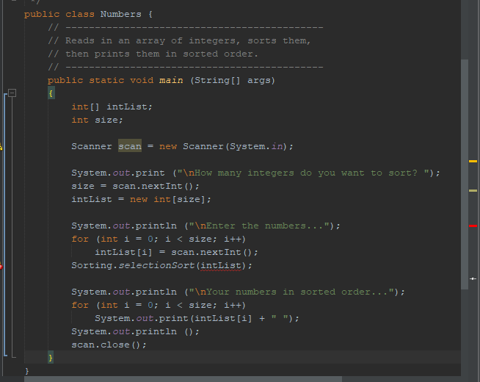

**//Salesperson**

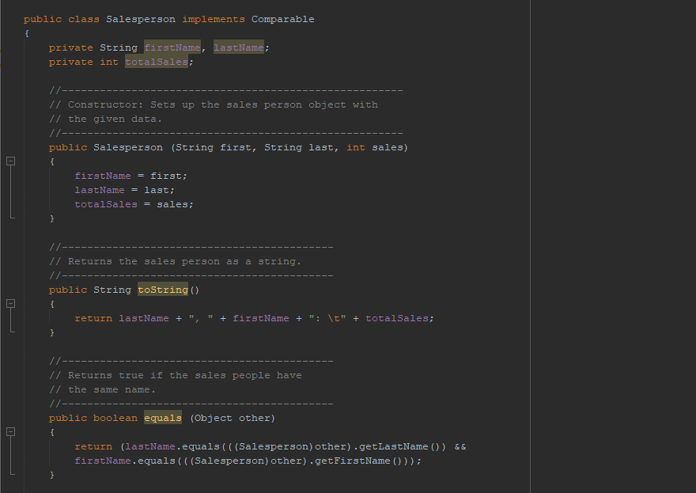

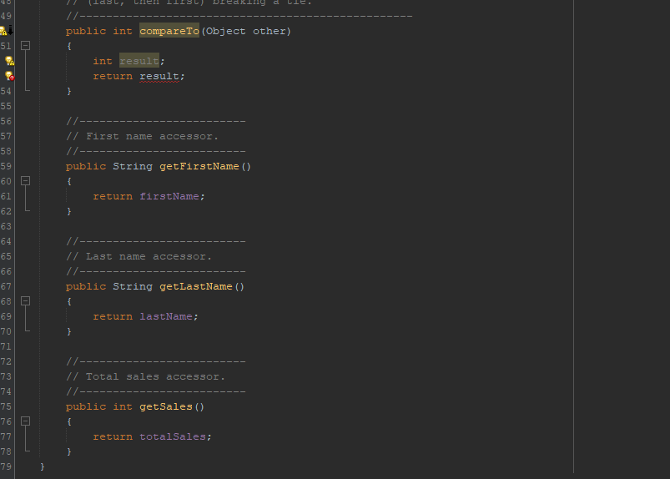

**//WeeklySales.java**

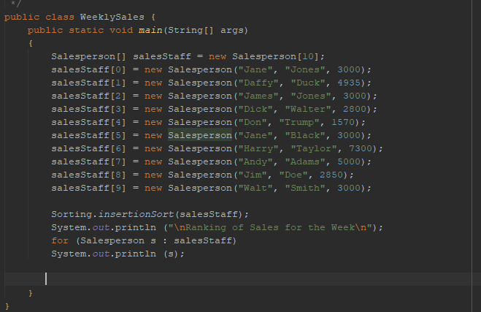

**Hasil Output error :**

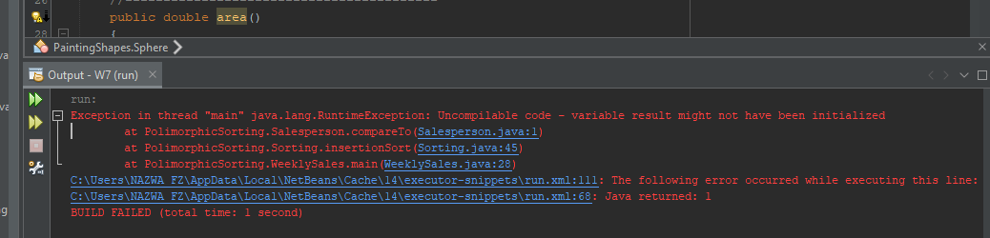

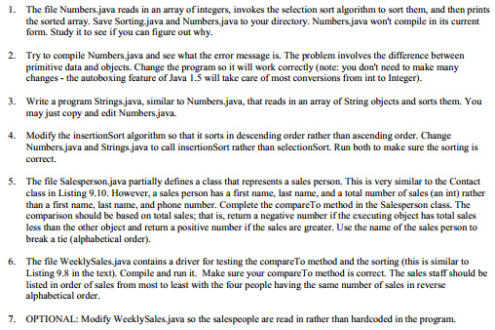

**Modify code :**

**//Number.java**

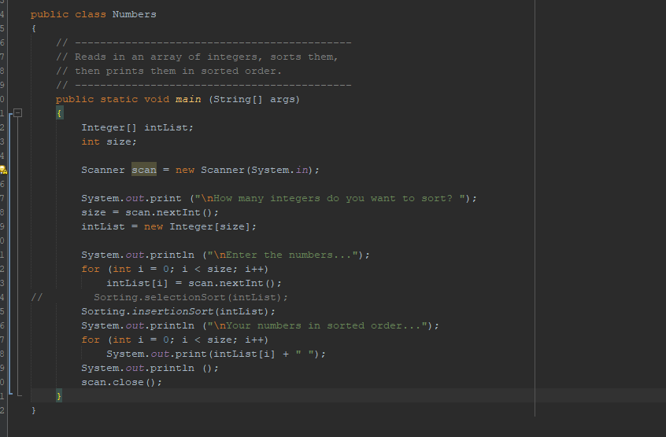

**//Salesperson.java**

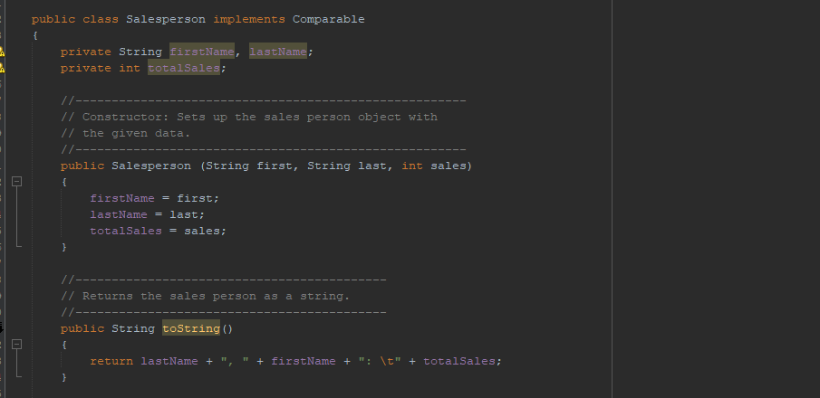

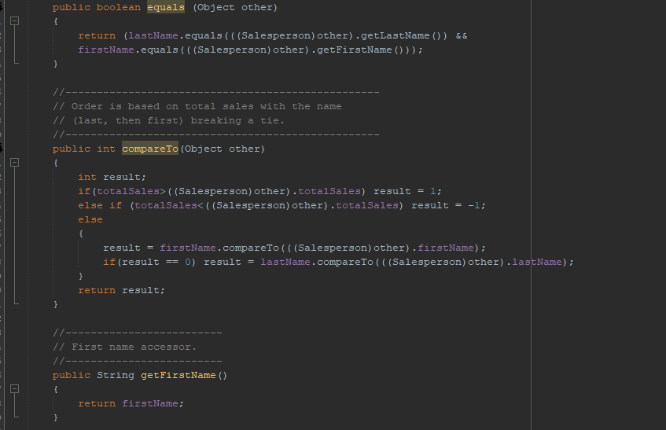

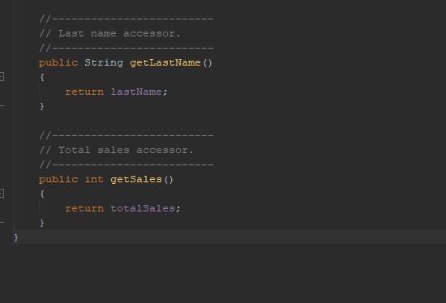

**//Sorting.java**

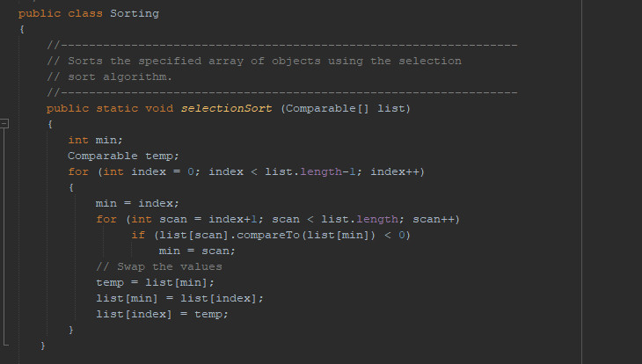

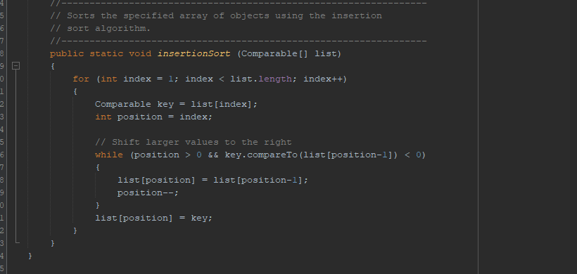

**//Strings.java**

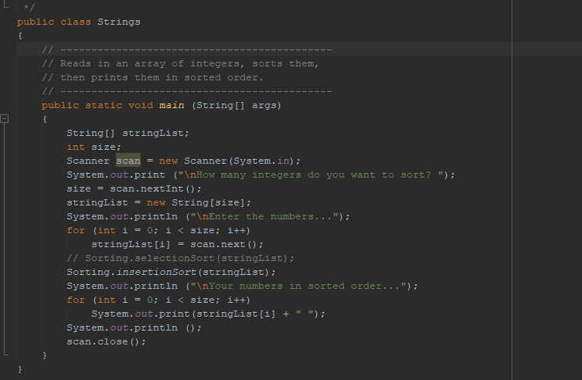

**//WeeklySales.java**

